- Preview the Query Builder Data Binding sample.
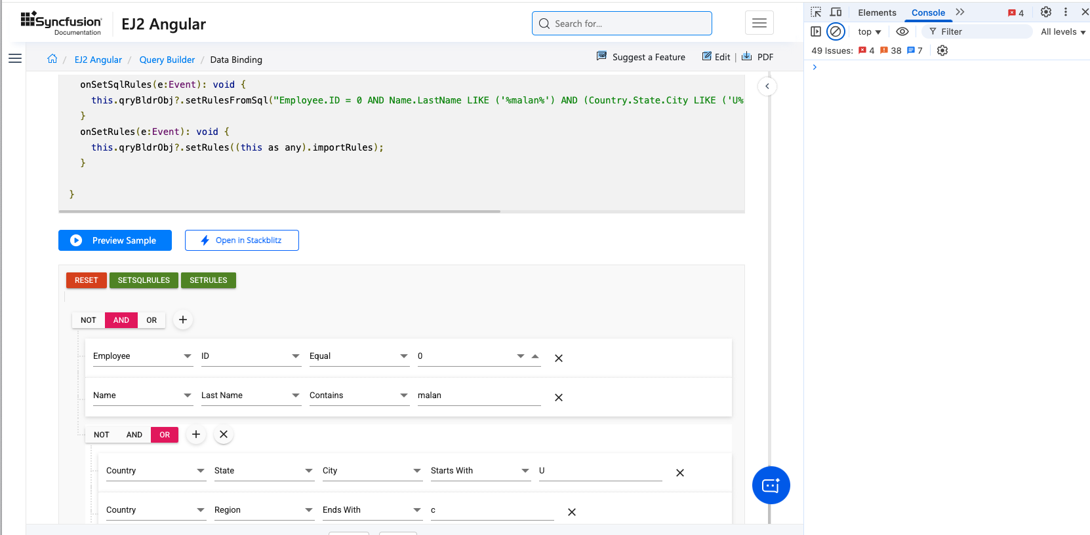

- Delete the 3 conditions in the second group.
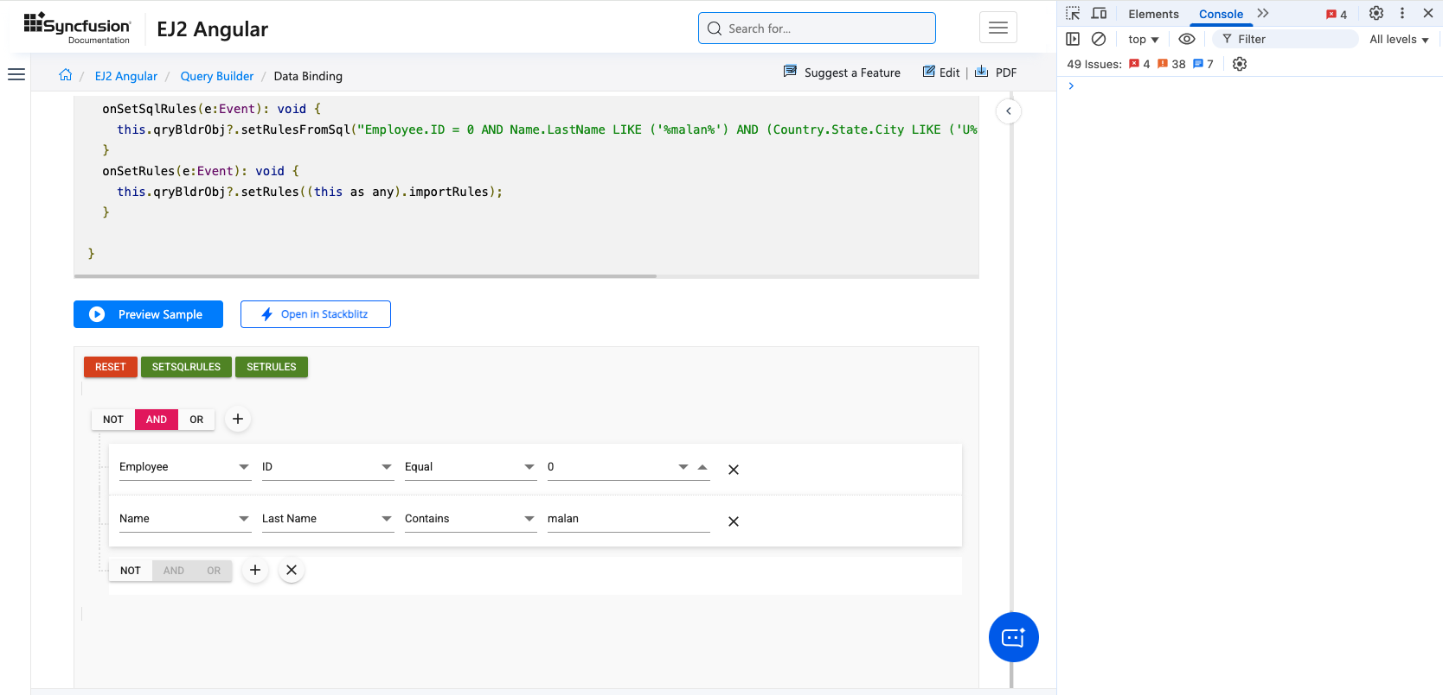

- Change the group condition of the first group from AND to OR. A TypeError: Cannot read properties of undefined (reading 'split') error is generated and the condition, add and delete buttons for the empty group disappear and are replaced with a textbox.
