Appendix

- The user can either select the canva size or self-defined the width(x-axis) and height(y-axis). *Not sure what is the measure unit used in Syncfusion, mm? um?
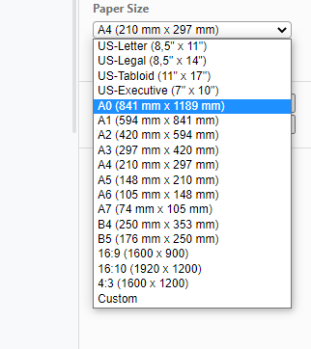

- The boundary or space (grid) which is beyond the selected size of the canva should be hidden or grey-out like the area marked with red color in the screenshot attached below. While the ruler must be located and aligned together with the canvas size too as shown like covered by the black box in screenshot below.

