Language: VB.net
SyncFusion Classes:
SyncFusion.Pdf.Parsing.PdfLoadedDocument
SyncFusion.Pdf.Graphics.PdfBrush
SyncFusion.Pdf.Graphics.PdfSolidBrush
Syncfusion.Pdf.Graphics.PdfCjkStandardFont
PdfCjkFontFamily.HeiseiMinchoW3

Code snippet:
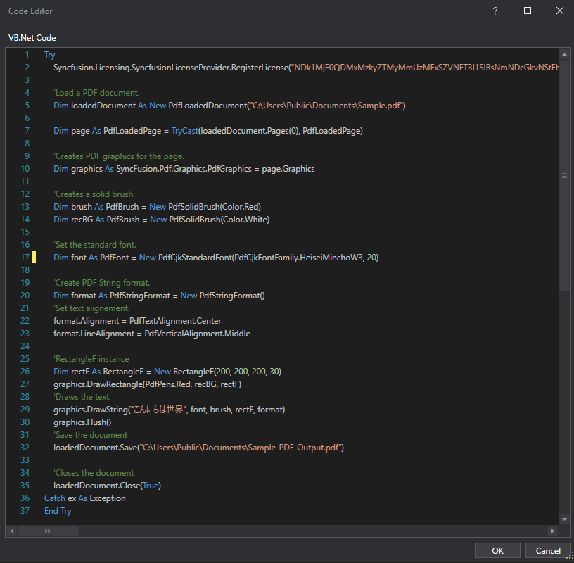

Error:
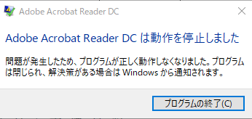

Additional Info: Not reproducible on the computer where it was generated. This error only displayed in other computer. No issue when the file is open in PDF Viewer or Browser.

Version of the reader:
