Prefix of icon on task description to show project status

Screenshot:

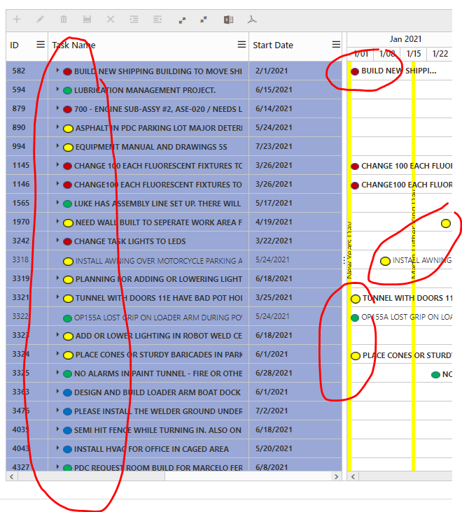

Snippet: PHP to generate the project source data;

Summary: Evaluate the task and assign the appropriate icon

…

if ($new_value == 1) {

$front_icon = "<img src='https://www.springvalleysystems.com/case/addwo/mobile/images/Behind_50.png'> "; //Behind_50.png TARGET_50.png Complete_50.png Risk_50.png

}

if ($new_value == 2) {

$front_icon = "<img src='https://www.springvalleysystems.com/case/addwo/mobile/images/TARGET_50.png'> "; //Behind_50.png TARGET_50.png Complete_50.png Risk_50.png

}

if ($new_value == 3) {

$front_icon = "<img src='https://www.springvalleysystems.com/case/addwo/mobile/images/Complete_50.png'> "; //Behind_50.png TARGET_50.png Complete_50.png Risk_50.png

}

if ($new_value == 4) {

$front_icon = "<img src='https://www.springvalleysystems.com/case/addwo/mobile/images/Risk_50.png'> "; //Behind_50.png TARGET_50.png Complete_50.png Risk_50.png

}

$str_task_name = $front_icon.trim(str_replace('\n','',str_replace('\r','',str_replace("'","~",$row_root['taskName']))));

…