Syncfusion Code Base: v18.4.0.49
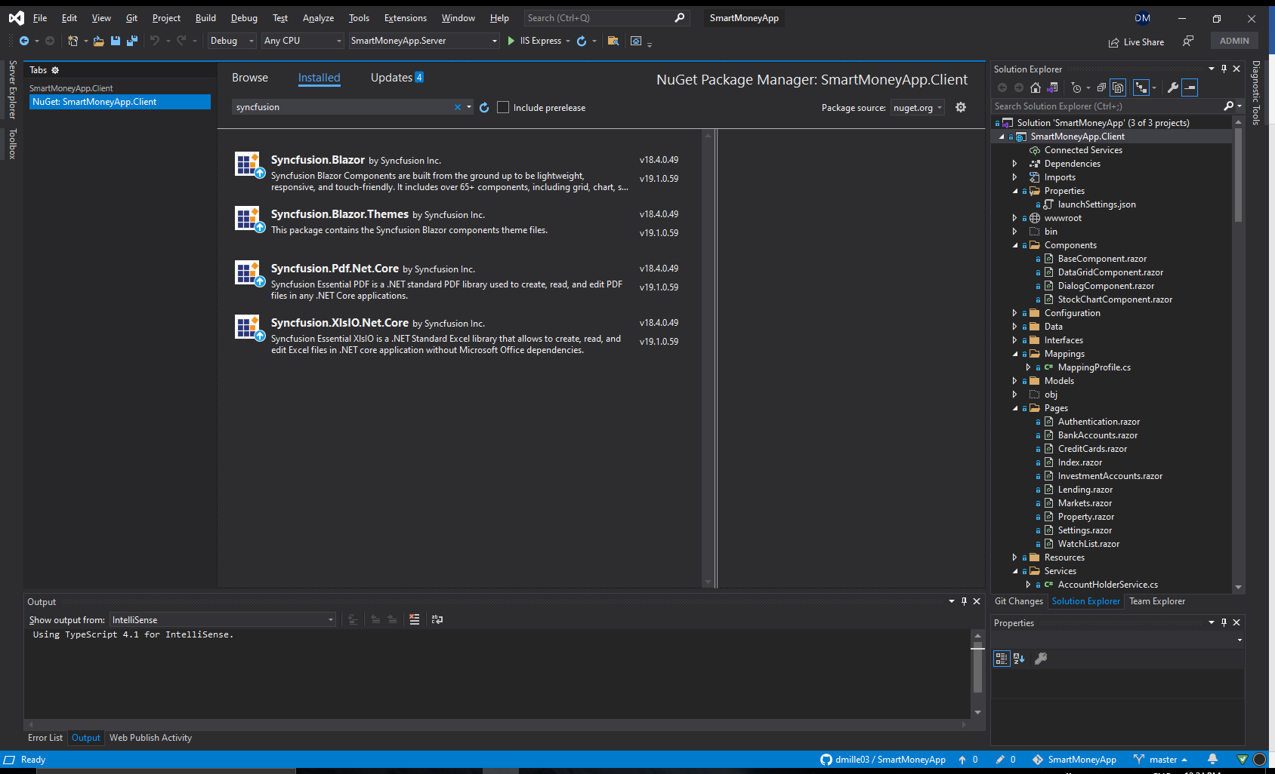

Syncfusion Stock Chart: v18.4.0.49
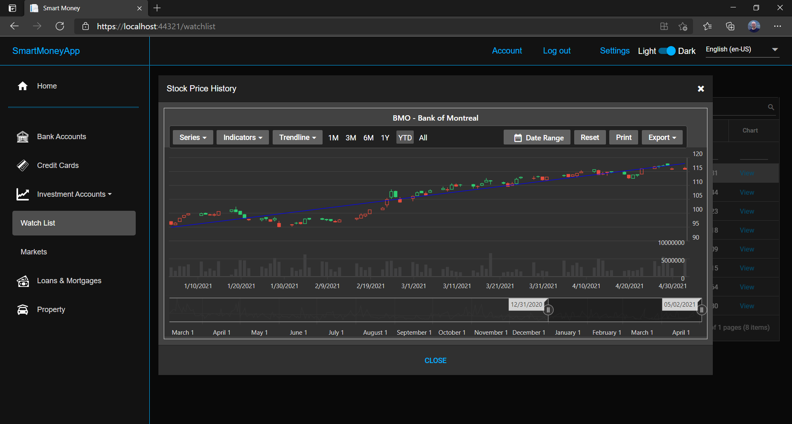

C# Source Code (v18.4.0.49)

@using Syncfusion.Blazor.Buttons
@inherits SmartMoneyApp.Client.Components.BaseComponent

@if (_stockChartDataList is null)
{
<div class="blazored-modal-content-message">
<div class="col-sm">
<SfSpinner Size="30" Type="SpinnerType.Material" Visible="true" CssClass="blazored-modal-spinner" Label="Loading..."></SfSpinner>
</div>
</div>
}
else
{
@if (IsBusy)
{
<div class="col-sm">
<SfSpinner Size="30" Type="SpinnerType.Material" Visible="true" CssClass="blazored-modal-spinner" Label="Loading..."></SfSpinner>
</div>
}

<div class="blazored-modal-content-message">
<SfStockChart @ref="_chart" Title="@ChartTitle" Theme="@_chartTheme" EnablePeriodSelector="true" EnableSelector="true" Width="100%" Height="100%">
<StockChartChartArea>
<StockChartChartAreaBorder Width="0"></StockChartChartAreaBorder>
</StockChartChartArea>
<StockChartPrimaryXAxis>
<StockChartAxisMajorGridLines Width="0"></StockChartAxisMajorGridLines>
<StockChartAxisCrosshairTooltip Enable="true"></StockChartAxisCrosshairTooltip>
</StockChartPrimaryXAxis>
<StockChartPrimaryYAxis LabelFormat="n0">
<StockChartAxisLineStyle Width="0"></StockChartAxisLineStyle>
</StockChartPrimaryYAxis>
<StockChartTooltipSettings Enable="true"></StockChartTooltipSettings>
<StockChartCrosshairSettings Enable="true"></StockChartCrosshairSettings>
<StockChartAxes>
<StockChartAxis RowIndex=1 Name="yAxis1" OpposedPosition="true">
</StockChartAxis>
</StockChartAxes>
<StockChartRows>
<StockChartRow Height="30%"></StockChartRow>
<StockChartRow Height="70%"></StockChartRow>
</StockChartRows>
<StockChartSeriesCollection>
<StockChartSeries DataSource="@_stockChartDataList" Type="ChartSeriesType.Candle"
XName="@nameof(StockChartData.Date)" YName="@nameof(StockChartData.Close)" YAxisName="yAxis1"
High="@nameof(StockChartData.High)" Low="@nameof(StockChartData.Low)"
Open="@nameof(StockChartData.Open)" Close="@nameof(StockChartData.Close)"
Volume="@nameof(StockChartData.Volume)" Name="@ChartTitle">
<StockChartTrendlines>
<StockChartTrendline Type="TrendlineTypes.Linear" EnableTooltip="false"></StockChartTrendline>
</StockChartTrendlines>
</StockChartSeries>
<StockChartSeries DataSource="@_stockChartDataList" Type="ChartSeriesType.Column"
XName="@nameof(StockChartData.Date)" YName="@nameof(StockChartData.Volume)"
High="@nameof(StockChartData.High)" Low="@nameof(StockChartData.Low)"
Name="@ChartTitle" EnableTooltip="false">
</StockChartSeries>
</StockChartSeriesCollection>
</SfStockChart>
</div>
}

<div class="blazored-modal-footer">
<SfButton CssClass="e-flat" IsPrimary="true" @onclick="CloseButtonClicked">@Localization[Resources.Close]</SfButton>
</div>

<style>
.blazored-modal-header {
background-color: var(--primary-header-color);
border-bottom: 0.5px solid rgba(0, 0, 0, 0.42);
padding: 0 0 0 0;
}

.blazored-modal {
background-color: var(--primary-content-color);
border: var(--primary-border-color);
padding: 0;
width: 70%;
height: 40%;
}

.blazored-modal-title {
background-color: var(--primary-header-color);
color: var(--primary-text-color);
padding: 1.0rem;
font-size: 1.0em;
}

.blazored-modal-content {
background-color: var(--primary-content-color);
padding: 0.0;
}

.blazored-modal-content-message {
background-color: var(--primary-content-color);
color: rgba(255, 255, 255, 0.7);
padding-block-start: 1%;
padding-block-end: 1%;
margin-left: 1%;
margin-right: 1%;
}

.blazored-modal-close {
color: var(--primary-icon-color);
padding-right: 2.0rem;
padding-top: 1.5rem;
}

.blazored-modal-footer {
border-top: 0.5px solid rgba(0, 0, 0, 0.42);
background-color: var(--primary-footer-color);
text-align: center;
padding-top: 15px;
padding-bottom: 15px;
}

.blazored-modal-topright .blazored-modal {
position: absolute;
top: 10%;
right: 10%;
}

.blazored-modal-spinner {
text-align: center;
}
</style>

@code {

[CascadingParameter]
BlazoredModalInstance ModalInstance { get; set; }

[Parameter]
public Security Security { get; set; }

private IStringLocalizer Localization { get; set; }
private ILogger<StockChartComponent> Logger { get; set; }

private string ChartTitle => $"{Security.Symbol} - {Security.Description}";
private ChartTheme _chartTheme = ChartTheme.MaterialDark;
private SfStockChart _chart;
private List<StockChartData> _stockChartDataList;

protected override async Task OnInitializedAsync()
{
await base.OnInitializedAsync();
Logger = LoggerFactory.CreateLogger<StockChartComponent>();
Logger.LogDebug($"Stock chart component instantiated");
Localization = LocalizationFactory.Create(typeof(Resources));

if (PreferencesService is not null)
{
_chartTheme = (ChartTheme) PreferencesService.GetTheme().ThemeCode;
}

if (Security is not null && _stockChartDataList is null)
{
_stockChartDataList = await AccountHolderService.GetStockChartDataAsync(Security);
}
}

private void CloseButtonClicked()
{
Logger.LogDebug($"Button 'Close' clicked, ModalResult.Cancelled is false");
ModalInstance.CloseAsync(ModalResult.Ok(false));
}

public override void Dispose()
{
Logger.LogDebug($"Entry point: {new System.Diagnostics.StackTrace()}");
((IDisposable)_chart)?.Dispose();
Logger.LogDebug($"Exit point: {new System.Diagnostics.StackTrace()}");
}
}

Syncfusion Code Base: v19.1.0.59
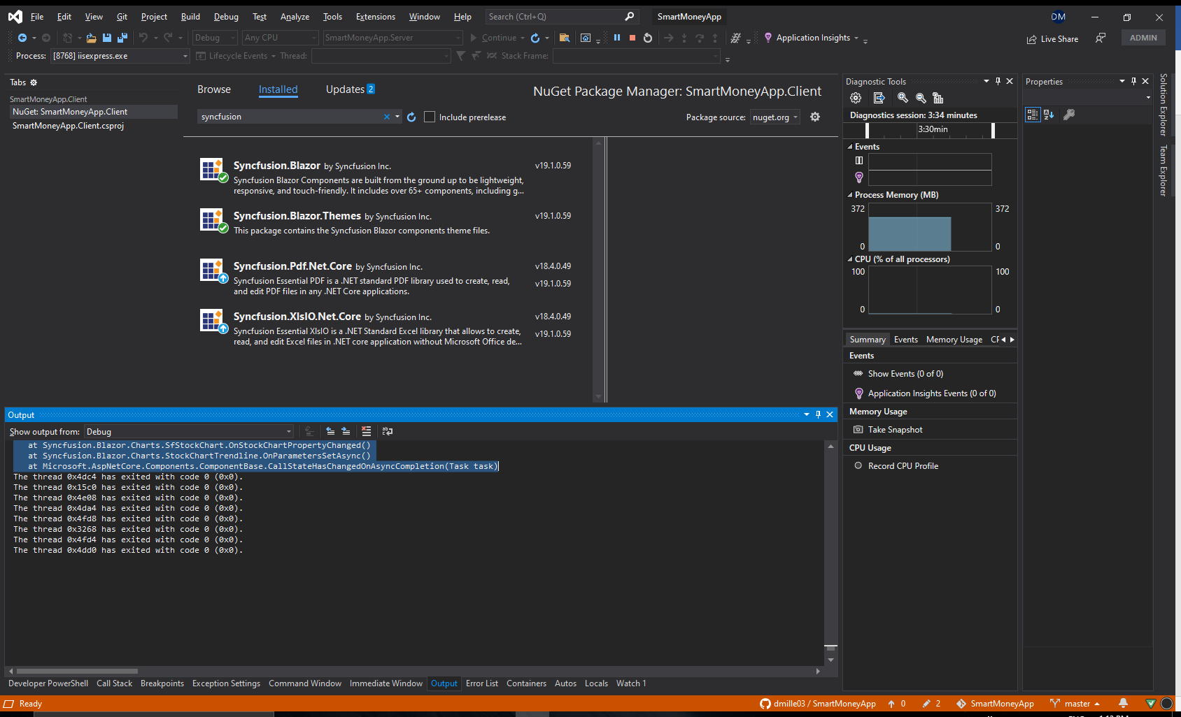

Syncfusion Stock Chart: v19.1.0.59
Notice that the toolbar is rendering differently than in previous version. Many null reference exceptions are being thrown from the Syncfusion stock chart control.
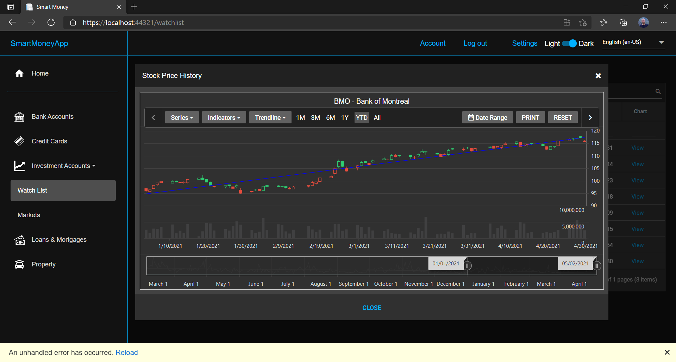
Syncfusion Stock Chart Exceptions: v19.1.0.59
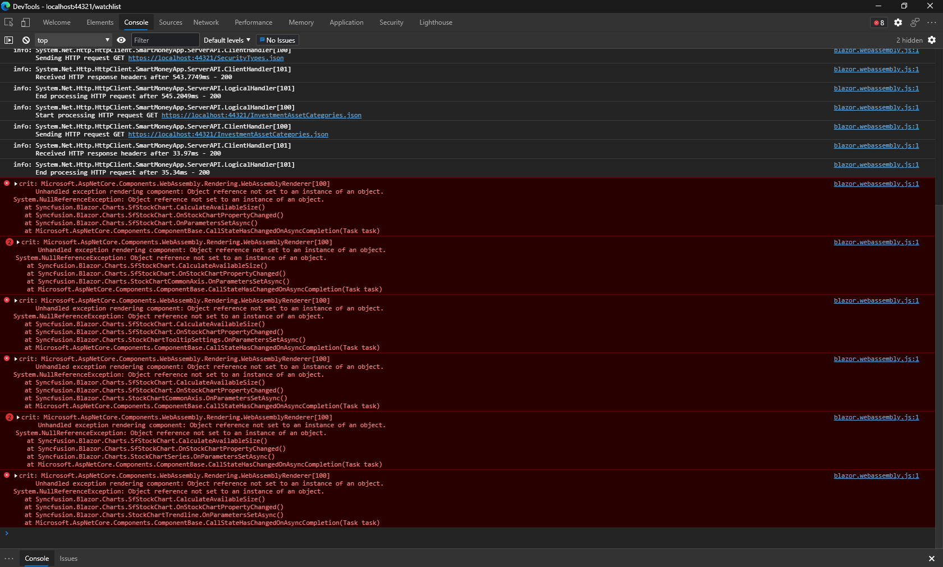

crit: Microsoft.AspNetCore.Components.WebAssembly.Rendering.WebAssemblyRenderer[100]
Unhandled exception rendering component: Object reference not set to an instance of an object.
System.NullReferenceException: Object reference not set to an instance of an object.
at Syncfusion.Blazor.Charts.SfStockChart.CalculateAvailableSize()
at Syncfusion.Blazor.Charts.SfStockChart.OnStockChartPropertyChanged()
at Syncfusion.Blazor.Charts.SfStockChart.OnParametersSetAsync()
at Microsoft.AspNetCore.Components.ComponentBase.CallStateHasChangedOnAsyncCompletion(Task task)
crit: Microsoft.AspNetCore.Components.WebAssembly.Rendering.WebAssemblyRenderer[100]
Unhandled exception rendering component: Object reference not set to an instance of an object.
System.NullReferenceException: Object reference not set to an instance of an object.
at Syncfusion.Blazor.Charts.SfStockChart.CalculateAvailableSize()
at Syncfusion.Blazor.Charts.SfStockChart.OnStockChartPropertyChanged()
at Syncfusion.Blazor.Charts.StockChartCommonAxis.OnParametersSetAsync()
at Microsoft.AspNetCore.Components.ComponentBase.CallStateHasChangedOnAsyncCompletion(Task task)
crit: Microsoft.AspNetCore.Components.WebAssembly.Rendering.WebAssemblyRenderer[100]
Unhandled exception rendering component: Object reference not set to an instance of an object.
System.NullReferenceException: Object reference not set to an instance of an object.
at Syncfusion.Blazor.Charts.SfStockChart.CalculateAvailableSize()
at Syncfusion.Blazor.Charts.SfStockChart.OnStockChartPropertyChanged()
at Syncfusion.Blazor.Charts.StockChartCommonAxis.OnParametersSetAsync()
at Microsoft.AspNetCore.Components.ComponentBase.CallStateHasChangedOnAsyncCompletion(Task task)
crit: Microsoft.AspNetCore.Components.WebAssembly.Rendering.WebAssemblyRenderer[100]
Unhandled exception rendering component: Object reference not set to an instance of an object.
System.NullReferenceException: Object reference not set to an instance of an object.
at Syncfusion.Blazor.Charts.SfStockChart.CalculateAvailableSize()
at Syncfusion.Blazor.Charts.SfStockChart.OnStockChartPropertyChanged()
at Syncfusion.Blazor.Charts.StockChartTooltipSettings.OnParametersSetAsync()
at Microsoft.AspNetCore.Components.ComponentBase.CallStateHasChangedOnAsyncCompletion(Task task)
crit: Microsoft.AspNetCore.Components.WebAssembly.Rendering.WebAssemblyRenderer[100]
Unhandled exception rendering component: Object reference not set to an instance of an object.
System.NullReferenceException: Object reference not set to an instance of an object.
at Syncfusion.Blazor.Charts.SfStockChart.CalculateAvailableSize()
at Syncfusion.Blazor.Charts.SfStockChart.OnStockChartPropertyChanged()
at Syncfusion.Blazor.Charts.StockChartCommonAxis.OnParametersSetAsync()
at Microsoft.AspNetCore.Components.ComponentBase.CallStateHasChangedOnAsyncCompletion(Task task)
crit: Microsoft.AspNetCore.Components.WebAssembly.Rendering.WebAssemblyRenderer[100]
Unhandled exception rendering component: Object reference not set to an instance of an object.
System.NullReferenceException: Object reference not set to an instance of an object.
at Syncfusion.Blazor.Charts.SfStockChart.CalculateAvailableSize()
at Syncfusion.Blazor.Charts.SfStockChart.OnStockChartPropertyChanged()
at Syncfusion.Blazor.Charts.StockChartSeries.OnParametersSetAsync()
at Microsoft.AspNetCore.Components.ComponentBase.CallStateHasChangedOnAsyncCompletion(Task task)
crit: Microsoft.AspNetCore.Components.WebAssembly.Rendering.WebAssemblyRenderer[100]
Unhandled exception rendering component: Object reference not set to an instance of an object.
System.NullReferenceException: Object reference not set to an instance of an object.
at Syncfusion.Blazor.Charts.SfStockChart.CalculateAvailableSize()
at Syncfusion.Blazor.Charts.SfStockChart.OnStockChartPropertyChanged()
at Syncfusion.Blazor.Charts.StockChartSeries.OnParametersSetAsync()
at Microsoft.AspNetCore.Components.ComponentBase.CallStateHasChangedOnAsyncCompletion(Task task)
crit: Microsoft.AspNetCore.Components.WebAssembly.Rendering.WebAssemblyRenderer[100]
Unhandled exception rendering component: Object reference not set to an instance of an object.
System.NullReferenceException: Object reference not set to an instance of an object.
at Syncfusion.Blazor.Charts.SfStockChart.CalculateAvailableSize()
at Syncfusion.Blazor.Charts.SfStockChart.OnStockChartPropertyChanged()
at Syncfusion.Blazor.Charts.StockChartTrendline.OnParametersSetAsync()
at Microsoft.AspNetCore.Components.ComponentBase.CallStateHasChangedOnAsyncCompletion(Task task)

C# Source Code (v19.1.0.59)
The v19 version of the Syncfusion code introduced a breaking change as the Syncfusion.Blazor.Charts.ChartTheme was replaced with Syncfusion.Blazor.Theme.
@using Syncfusion.Blazor.Buttons
@using Theme = Syncfusion.Blazor.Theme
@inherits SmartMoneyApp.Client.Components.BaseComponent

@if (_stockChartDataList is null)
{
<div class="blazored-modal-content-message">
<div class="col-sm">
<SfSpinner Size="30" Type="SpinnerType.Material" Visible="true" CssClass="blazored-modal-spinner" Label="Loading..."></SfSpinner>
</div>
</div>
}
else
{
@if (IsBusy)
{
<div class="col-sm">
<SfSpinner Size="30" Type="SpinnerType.Material" Visible="true" CssClass="blazored-modal-spinner" Label="Loading..."></SfSpinner>
</div>
}

<div class="blazored-modal-content-message">
<SfStockChart @ref="_chart" Title="@ChartTitle" Theme="@_chartTheme" EnablePeriodSelector="true" EnableSelector="true" Width="100%" Height="100%">
<StockChartChartArea>
<StockChartChartAreaBorder Width="0"></StockChartChartAreaBorder>
</StockChartChartArea>
<StockChartPrimaryXAxis>
<StockChartAxisMajorGridLines Width="0"></StockChartAxisMajorGridLines>
<StockChartAxisCrosshairTooltip Enable="true"></StockChartAxisCrosshairTooltip>
</StockChartPrimaryXAxis>
<StockChartPrimaryYAxis LabelFormat="n0">
<StockChartAxisLineStyle Width="0"></StockChartAxisLineStyle>
</StockChartPrimaryYAxis>
<StockChartTooltipSettings Enable="true"></StockChartTooltipSettings>
<StockChartCrosshairSettings Enable="true"></StockChartCrosshairSettings>
<StockChartAxes>
<StockChartAxis RowIndex=1 Name="yAxis1" OpposedPosition="true">
</StockChartAxis>
</StockChartAxes>
<StockChartRows>
<StockChartRow Height="30%"></StockChartRow>
<StockChartRow Height="70%"></StockChartRow>
</StockChartRows>
<StockChartSeriesCollection>
<StockChartSeries DataSource="@_stockChartDataList" Type="ChartSeriesType.Candle"
XName="@nameof(StockChartData.Date)" YName="@nameof(StockChartData.Close)" YAxisName="yAxis1"
High="@nameof(StockChartData.High)" Low="@nameof(StockChartData.Low)"
Open="@nameof(StockChartData.Open)" Close="@nameof(StockChartData.Close)"
Volume="@nameof(StockChartData.Volume)" Name="@ChartTitle">
<StockChartTrendlines>
<StockChartTrendline Type="TrendlineTypes.Linear" EnableTooltip="false"></StockChartTrendline>
</StockChartTrendlines>
</StockChartSeries>
<StockChartSeries DataSource="@_stockChartDataList" Type="ChartSeriesType.Column"
XName="@nameof(StockChartData.Date)" YName="@nameof(StockChartData.Volume)"
High="@nameof(StockChartData.High)" Low="@nameof(StockChartData.Low)"
Name="@ChartTitle" EnableTooltip="false">
</StockChartSeries>
</StockChartSeriesCollection>
</SfStockChart>
</div>
}

<div class="blazored-modal-footer">
<SfButton CssClass="e-flat" IsPrimary="true" @onclick="CloseButtonClicked">@Localization[Resources.Close]</SfButton>
</div>

<style>
.blazored-modal-header {
background-color: var(--primary-header-color);
border-bottom: 0.5px solid rgba(0, 0, 0, 0.42);
padding: 0 0 0 0;
}

.blazored-modal {
background-color: var(--primary-content-color);
border: var(--primary-border-color);
padding: 0;
width: 70%;
height: 40%;
}

.blazored-modal-title {
background-color: var(--primary-header-color);
color: var(--primary-text-color);
padding: 1.0rem;
font-size: 1.0em;
}

.blazored-modal-content {
background-color: var(--primary-content-color);
padding: 0.0;
}

.blazored-modal-content-message {
background-color: var(--primary-content-color);
color: rgba(255, 255, 255, 0.7);
padding-block-start: 1%;
padding-block-end: 1%;
margin-left: 1%;
margin-right: 1%;
}

.blazored-modal-close {
color: var(--primary-icon-color);
padding-right: 2.0rem;
padding-top: 1.5rem;
}

.blazored-modal-footer {
border-top: 0.5px solid rgba(0, 0, 0, 0.42);
background-color: var(--primary-footer-color);
text-align: center;
padding-top: 15px;
padding-bottom: 15px;
}

.blazored-modal-topright .blazored-modal {
position: absolute;
top: 10%;
right: 10%;
}

.blazored-modal-spinner {
text-align: center;
}
</style>

@code {

[CascadingParameter]
BlazoredModalInstance ModalInstance { get; set; }

[Parameter]
public Security Security { get; set; }

private IStringLocalizer Localization { get; set; }
private ILogger<StockChartComponent> Logger { get; set; }

private string ChartTitle => $"{Security.Symbol} - {Security.Description}";
private Theme _chartTheme = Theme.MaterialDark;
private SfStockChart _chart;
private List<StockChartData> _stockChartDataList;

protected override async Task OnInitializedAsync()
{
await base.OnInitializedAsync();
Logger = LoggerFactory.CreateLogger<StockChartComponent>();
Logger.LogDebug($"Stock chart component instantiated");
Localization = LocalizationFactory.Create(typeof(Resources));

if (PreferencesService is not null)
{
_chartTheme = (Theme) PreferencesService.GetTheme().ThemeCode;
}

if (Security is not null && _stockChartDataList is null)
{
_stockChartDataList = await AccountHolderService.GetStockChartDataAsync(Security);
}
}

private void CloseButtonClicked()
{
Logger.LogDebug($"Button 'Close' clicked, ModalResult.Cancelled is false");
ModalInstance.CloseAsync(ModalResult.Ok(false));
}

public override void Dispose()
{
Logger.LogDebug($"Entry point: {new System.Diagnostics.StackTrace()}");
((IDisposable)_chart)?.Dispose();
Logger.LogDebug($"Exit point: {new System.Diagnostics.StackTrace()}");
}
}

