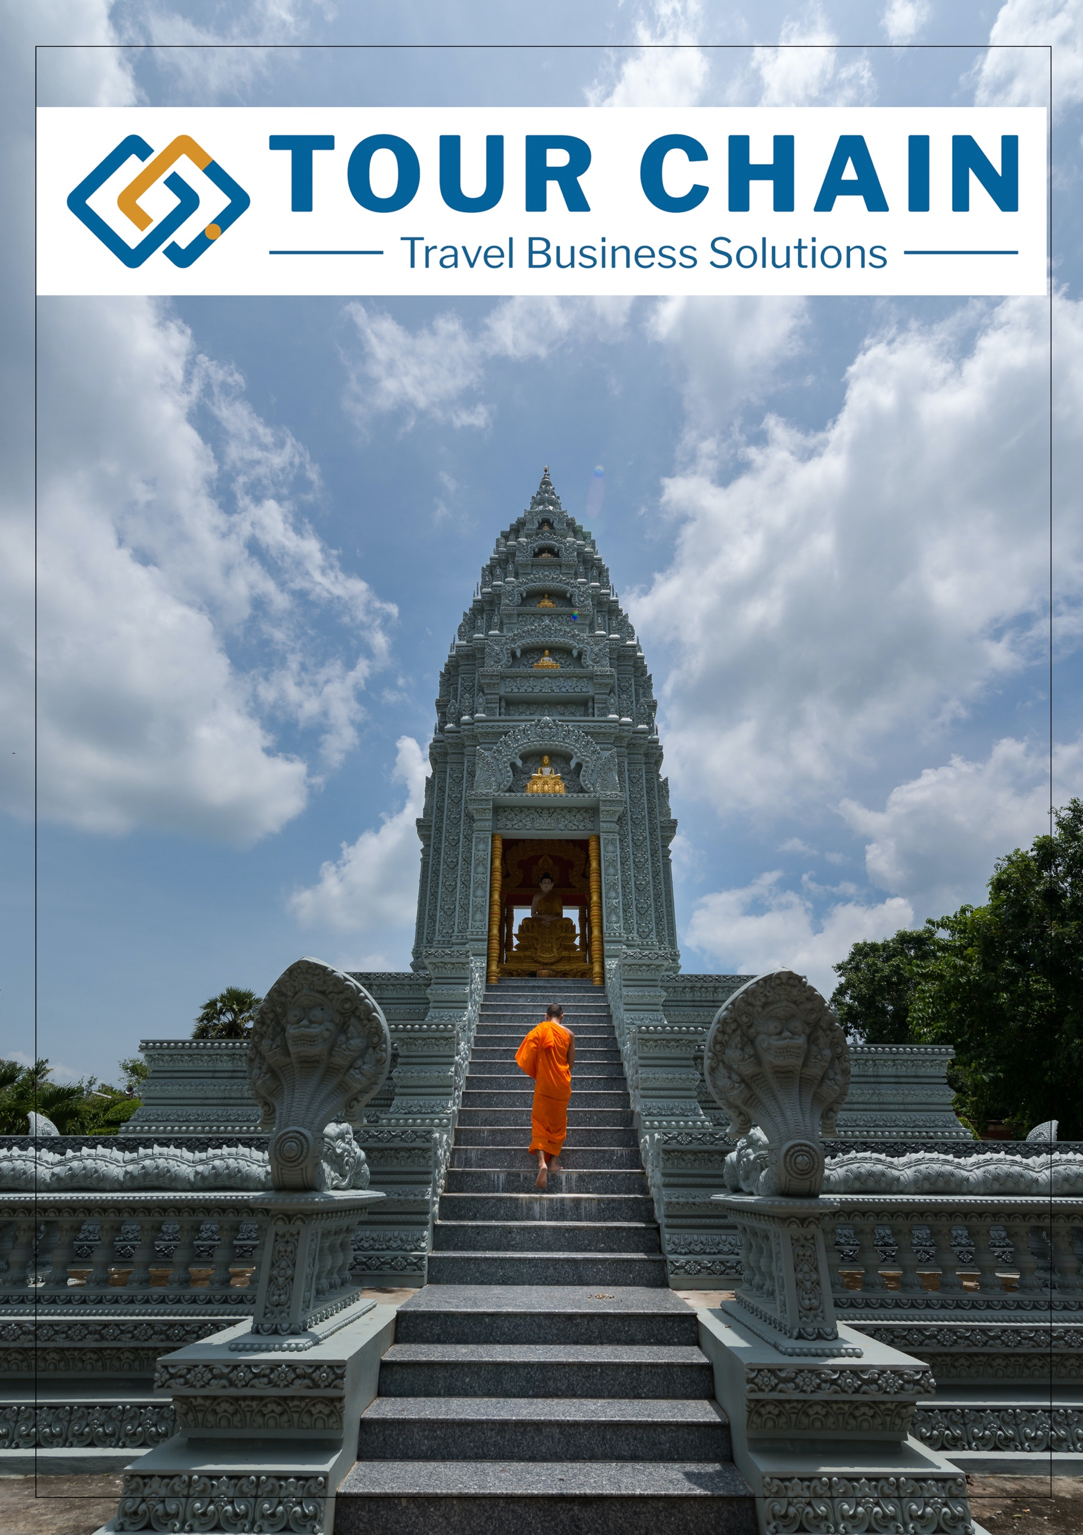

 | PROPOSAL INFORMATION

Singapore - Kuala Lumpur - RCI
27 Jan, 2021
Booking code: QN200128
Trip style:
Prepared on 18 Jan, 2021
By Tran Le Bao Quoc
quoc@tourchain.net -


TABLE OF CONTENTS
Your Travel Route
Itinerary Overview
Client information
Flight Summary
Trasfer Summary
Itinerary in Details
Your Quotation
Your Accommodation
Terms and Conditions

ITINERARY OVERVIEW

Travel dates: | 27 Jan, 2021
Destinations: | Vung Tau,
Room Type/preference:
Food allergies/preference:
Trip style:

CLIENT INFORMATION

Full Name | DOB | Nationality |  | Requirement
1. Adult1 / -- -- |  | --
2. Adult2 / -- -- |  | --
3. Adult3 / -- -- |  | --
4. Adult4 / -- -- |  | --
5. Adult5 / -- -- |  | --
6. Adult6 / -- -- |  | --
7. Adult7 / -- -- |  | --
8. Adult8 / -- -- |  | --
9. Adult9 / -- -- |  | --
10. Adult10 / -- -- |  | --
11. Adult11 / -- -- |  | --
12. Adult12 / -- -- |  | --
13. Adult13 / -- -- |  | --
14. Adult14 / -- -- |  | --
15. Adult15 / -- -- |  | --

FLIGHT SUMMARY

Date | Flight Details | Booked By | Status
01 Feb, 2019 | Route: 1.Noi Nai (HAN) - Singaport (SIN)  Time(Departure/arrival): (00:00 - 00:00)  Class:
01 Feb, 2019 | Route: 2. -  Time(Departure/arrival): (00:00 - 00:00)  Class:

HOTEL SUMMARY

City | Hotel Information | Status
Vung Tau | Hotel: Cruise  Room Category:  Address:  Nights: 1  Date(Arr./Dep.): 27 Jan, 2021 - 28 Jan, 2021
Vung Tau | Hotel: Cruise - Tour Leader  Room Category:  Address:  Nights: 1  Date(Arr./Dep.): 27 Jan, 2021 - 28 Jan, 2021

ITINERARY IN DETAILS

DAY (01)- 27 Jan, 2021 - Singapore

Accommodation
Meals
Departure Time
Distance Duration
Activities

: Bicycle  Cruise  Train  Bus Trekking  Cable Car  Flight  Kayak



DAY (05)- 31 Jan, 2021 - Ninh Binh

Accommodation
Meals
Departure Time
Distance Duration
Activities

Little remains of the once impressive citadel of Hoa Lu, the ancient capital of the Dinh and Le Dynasties dating back to the 11th century. Temples that are still standing include the royal temple of the early Le Dynasty, Dai Hanh and Dinh Tien Hoang, another royal temple which contains a statue of Emperor Dinh Bo Linh and his sons. The energetic may undertake the climb of some 200 steps to explore the temples and for a rewarding bird's-eye view of the surrounding countryside.
Today Hoa Lu, and the surrounding province of Ninh Binh are better known for their outstanding natural beauty and the landscape with unusual rock formations jutting out of the rice paddies means the area is sometimes referred to as Ha Long Bay on land.
Take to the river and enjoy the tranquil journey by rowing boat to the remarkable caves and pagodas of Tam Coc and Bich Dong. En route you'll traverse a scenic landscape of rice fields and karst towers. Some of these caves in this region were used by the Viet Minh to hide from the French during the First Indochina War and now contain stalactites that have been carved into Buddhist images, as well as hollow stalactites that mimic flute-like sounds when played.

https://www.pinclipart.com/picdir/big/573-5739237_kayak-clipart-boat-oar-kayak-clipart-png-transparent.png

TESTING

DAY (01)- 27 Jan, 2021 - Vung Tau

Accommodation
Meals
Departure Time
Distance Duration
Activities

Cruise - undefined(1 nights)Cruise - undefined(1 nights)

YOUR QUOTATION
VIETNAM Tour quote - non - Commissionable
English Template | Total Service Price (VND per person)
English Template | (15 - -1) Pax | SGLSuppl
Total Landing Service  Total Accommodation  Total: | ₫20,362,644  ₫14,007,262  ₫34,369,906 | -

YOUR ACCOMMODATION

DESTINATION OVERVIEW

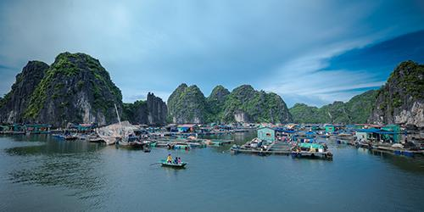 | 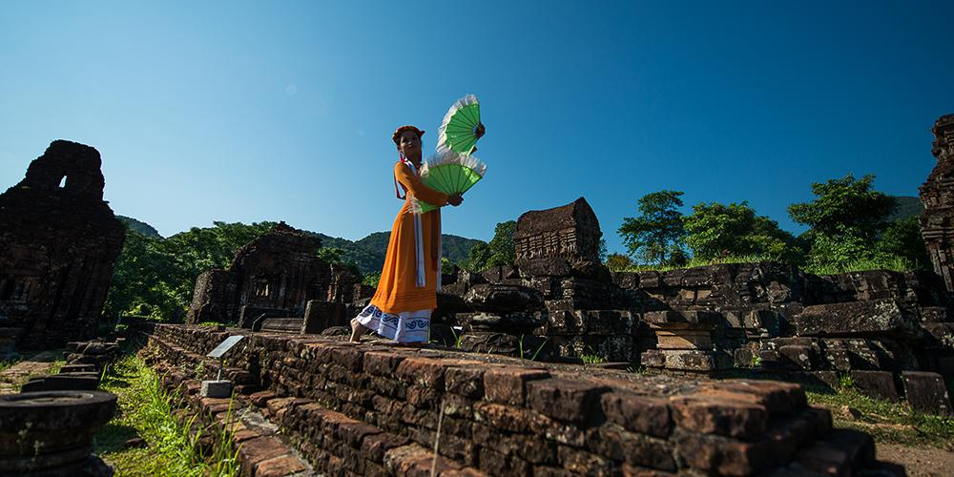 | 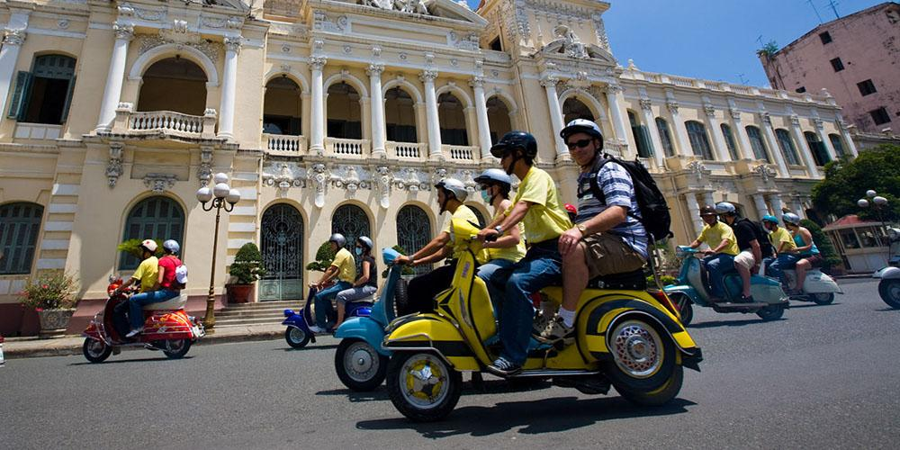

TERMS & CONDITIONS

DESTINATION OVERVIEWS

VIETNAM
Lorem ipsum dolor sit amet, consectetur adipiscing elit. Morbi at nibh at lectus dignissim consequat. Sed quam arcu, interdum quis metus in, faucibus mattis erat. Etiam vel vestibulum tellus, eget lacinia libero. Phasellus in semper urna. Etiam molestie arcu ac ante eleifend, et feugiat leo vulputate. Vestibulum a massa a turpis dignissim volutpat. Vivamus rutrum, mi in facilisis efficitur, ligula lorem laoreet velit, nec elementum libero dui ut sapien. Aliquam commodo scelerisque neque, non tristique lorem aliquet posuere. Mauris libero libero, mattis non vehicula in, eleifend eu nunc. | COUNTRY FACTS
 | Capital City  Time Zone  International  Currency  Population  Language  Largest cities | Hanoi  UTC +7  +84  Vietnamese Dong  96.3 million (April 2018)  Vietnamese  Hanoi, Ho Chi Minh, Danang, ....
WEATHER
Vietnam has a tropical climate with two distinct seasons: wet and dry.
The wet season is generally from April to October while the dry season runs from November to March. It is good to note that Vietnam's climate varies depending on the time of year and geographic location. Overall, when the weather isn't ideal in one area, it may be great in another.

 | Jan | Feb | Mar | Apr | May | Jun | Jul | Aug | Sep | Oct | Nov | Dec
North
South

 | Pleasantly warm  20 - 30^{O}C |  | Monsoon  25 - 35^{O}C |  | Hot & Dry  25 - 35^{O}C

PUBLIC HOLIDAYS
New Year's Day Wed, Jan 1, 2020
Lunar New Year Jan 23 – 29, 2020
Vietnamese New Year's Eve Fri, Jan 24, 2020
Hùng Kings' Festival Thu, Apr 2, 2020
Reunification Day Thu, Apr 30, 2020
Labour Day Fri, May 1, 2020
Independence Day Wed, Sep 2, 202

